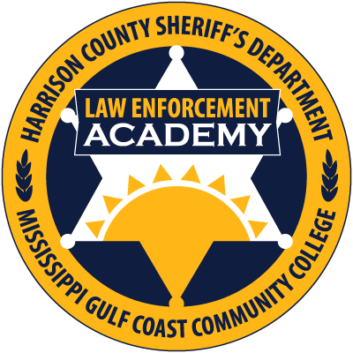

“Supervision and Leadership Level II”
“Hosted by the Harrison County Law Enforcement Training Academy July 24-26, 2017”

Course Duration: 24 hours

Max. Number of Students: 40

Instructional Setting: Classroom

COURSE DESCRIPTION:
This course is designed to ensure a quality presentation of advanced supervisory skills training for Supervisors and soon to be Managers, in order to assist their subordinates in being successful law enforcement officers by creating a professional work environment. The course is designed to teach the skills, techniques and principles required to be a productive, diversified supervisor, leader and manager.

Topics Include:
- Overview and course introduction
- Leadership Styles
- Twenty Common Mistakes of Supervisors and Managers
- The Six Step Problem Solving Method
- Ethics
- Team Building
- Motivational Theories
- Policy Development
- Policy Development Continued
- Planning
- Budgeting
- Interpersonal Communication Skills
- Stress Management
- Dealing with the Media
- Supervising in Today’s Society
- Value Driven Leadership
- Review and Test

INSTRUCTIONAL GOAL
To instill professional attitudes in supervisors and soon to be managers, as well as providing them with the skills, techniques, and basic concepts of modern supervision principles. An understanding of these concepts is fundamental for supervisors to be successful as mentors, trainers, and as leaders of their agencies. A properly trained professional supervisor is one of the best weapons any law enforcement agency can have in their arsenal, as they will pass on their training and professional attitude to the younger officers. In today’s litigious society, you can help to avoid unnecessary litigation due to “failure to train” or “improper training” of supervisors and officers alike, by affording your officers the proper tools and skills needed to function in modern law enforcement. Global Police Solutions, LLC is committed to our clients and believes in “Instilling professionalism through training”.
To register online, or for more information on Global Police Solutions, please visit our website at:
www.globalpolicesolutions.com

Global Police Solutions, LLC is a preferred and featured training provider with PoliceOne.com for advanced law enforcement training throughout the United States and Abroad.

Dates and Locations: July 24-26, 2017
Class Times: 0800hrs-1700hrs

Harrison County Law Enforcement Training Academy
1400 Leggett Drive
Biloxi, MS 39530 Phone: 228-435-3165

Course Fee: $329

Instructor: James C. Lilley - The Director of Global Police Solutions, LLC, Jim brings with him over twenty-five years of law enforcement experience both Nationally and Internationally. He holds a Bachelor of Science degree in Criminal Justice as well as an ICITAP Master Instructor certification, and is a member of the International Law Enforcement Educators and Trainers Association. Jim is well diversified in law enforcement, and has served in such supervisory and management roles as a Corporal, Detective, Major Level Narcotics Task Force Agent, Detective Sergeant, Patrol Sergeant, Training Sergeant and as a Training Division Commander/Lieutenant. While serving four years in Iraq with the police training mission, Jim served as a Senior Mentor, Lead Trainer, Training Center Support Team Leader, and as the Acting Regional Commander for AAB 5, Southern Iraq where he received a Certificate of Appreciation for Dedication and Initiative from Lieutenant General Helmick, USA, Commanding General, Multi-National Security Transition Command-Iraq. Jim is dedicated to presenting professional, “Hands On” law enforcement training, and encourages students by engaging them in class and group discussions. Come experience the Global Police Solutions way of advanced law enforcement training. Your officers will gain the skills, knowledge, and techniques required to motivate themselves and inspire other officers, as well as the communities they serve.

“Professional Training for Today’s Law Enforcement”
WWW.GLOBALPOLICESOLUTIONS.COM
Call Us Toll Free At: 855-4GPSTRAINING

