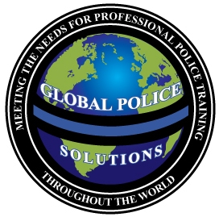

“First Line Supervision”

“Hosted by the Harrison County Law Enforcement Training Academy February 6-8, 2017”

Course Duration: 24 hours

Max. Number of Students: 35

Instructional Setting: Classroom

COURSE DESCRIPTION:
This course is designed to ensure a quality presentation of supervisory skills training for First Line Supervisors, so they can assist their subordinates in being successful law enforcement officers. The course is designed to teach basic skills, techniques and concepts of supervision, with an emphasis on “People Skills”, Communications, and Ethics.

Topics Include:

- The Role of the Supervisor
- Being a Motivator, a Trainer, and a Mentor
- The Role of Law Enforcement as it relates to Human Rights
- Law Enforcement Code of Ethics
- Change Management and why people resist change
- The Principles of Community Policing
- Delegation and “Formal Authority”
- The importance of Motivation as a Supervisor
- The Hierarchy of Needs Theory (Maslow)
- The Theory of Human Motives
- Social changes that affect Law Enforcement in today’s society
- The value of Goal Setting
- Communication and the Supervisor
- The process of communication and the barriers that affect such
- Active Listening Skills
- Handling complaints
- Planning (Includes class exercises)
- Goal of the F.T.O. Program

INSTRUCTIONAL GOAL:
To familiarize First Line Supervisors with the skills, techniques, and basic concepts of supervision. An understanding of these concepts is fundamental for First Line Supervisors to be successful as mentors, trainers, and as leaders. A properly trained professional supervisor is one of the best weapons any law enforcement agency can have in their arsenal, as they will pass on their training and professional attitude to the younger officers. In today’s litigious society, you can help to avoid unnecessary litigation due to “failure to train” or “improper training” of supervisors and officers alike, by affording your officers the proper tools and skills needed to function in modern law enforcement. Global Police Solutions, LLC is committed to our clients and believes in “Instilling professionalism through training”.
To register online, or for more information on Global Police Solutions, please visit our website at:
www.globalpolicesolutions.com

Global Police Solutions, LLC is an approved advanced LE training provider, who understands the concerns and needs of today’s law enforcement.

Dates and Location: February 6-8, 2017

Mississippi Gulf Coast Community College
Gulf Harbor Room, AMTC Building
10298 Express Drive
Gulfport, Mississippi 39503

Course Fee: $295

Instructor: James C. Lilley - The Director of Global Police Solutions, LLC, Jim brings with him over twenty-five years of law enforcement experience both Nationally and Internationally. He holds a Bachelor of Science degree in Criminal Justice as well as an ICITAP Master Instructor certification, and is a member of the International Law Enforcement Educators and Trainers Association. Jim is well diversified in law enforcement, and has served in such supervisory and management roles as a Corporal, Detective, Major Level Narcotics Task Force Agent, Detective Sergeant, Patrol Sergeant, Training Sergeant and as a Training Division Commander/Lieutenant. While serving four years in Iraq with the police training mission, Jim served as a Senior Mentor, Lead Trainer, Training Center Support Team Leader, and as the Acting Regional Commander for AAB 5, Southern Iraq where he received a Certificate of Appreciation for Dedication and Initiative from Lieutenant General Helmick, USA, Commanding General, Multi-National Security Transition Command-Iraq.

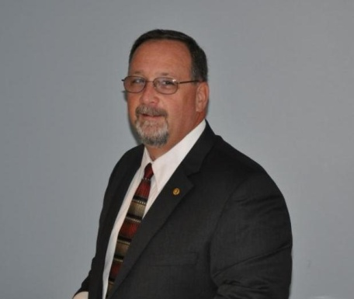

“Professional Training for Today’s Law Enforcement”
WWW.GLOBALPOLICESOLUTIONS.COM
Call Us Toll Free At: 855-4GPSTRAINING

