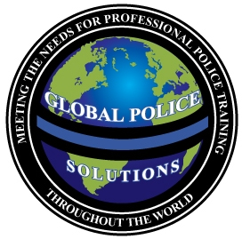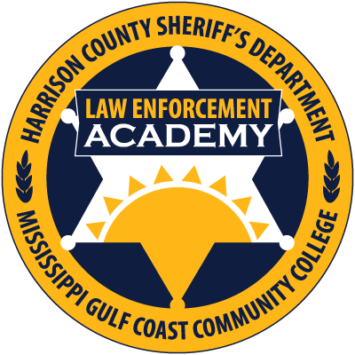

“INTERVIEW AND INTERROGATION LEVEL I”

“Hosted by the Harrison County Sheriff’s Office Law Enforcement Academy –January 30-31, 2017”

Course Duration: 16 hours

Max. Number of Students: 30

Instructional Setting: Classroom

Instructor: James C. Lilley
ICITAP Master Instructor
Former Detective Sergeant and
Major Level Narcotics Task Force Agent

COURSE DESCRIPTION:
This course is designed to provide the law enforcement officer with the knowledge, skills, and techniques necessary when conducting criminal interviews and interrogations, with an emphasis on Miranda use, communication and listening skills, body language, as well as the importance of proper documentation of the interview or interrogation.

Topics include:

- Interview or Interrogation?
- The Purpose of an Interview
- The Purpose of an Interrogation
- Guidelines for Conducting and Interview or an Interrogation
- Proper Locations to Conduct and Interview or an Interrogation
- Planning and Preparing the Interview or Interrogation
- Background Information; Knowing Your Case!
- When is Miranda Required?
- Does the Accused Have the Capacity to Understand Their Miranda Rights?
- Has the Accused Invoked Their Miranda Rights?
- How Many Investigators Are Too Many?
- Practice Good Listening Skills
- Ask Open Ended Questions
- Paralinguistic Cues
- Physiological Changes
- The Power of Persuasion
- Documenting the Interview or Interrogation
- What to Avoid When Conducting an Interview or an Interrogation
- Who Has the Authority to Offer a Deal?

Global Police Solutions, LLC is an approved advanced law enforcement training company, who provides professional training for today’s law enforcement throughout the United States and Abroad.

Dates and Location: January 30-31, 2017

Mississippi Gulf Coast Community College
Gulf Harbor Room, AMTC Building
10298 Express Drive
Gulfport, Mississippi 39503
To register for this course, or to learn more about Global Police Solutions,

Visit our website at:
www.globalpolicesolutions.com

Course Fee: $249

INSTRUCTOR:
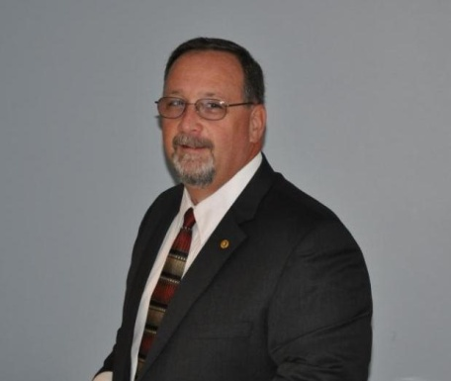

The Director of Global Police Solutions, LLC, Jim brings with him over twenty-five years of law enforcement experience. During his law enforcement career, Jim rose through the ranks from patrolman to the Training Division Commander/Lieutenant with the Horry County Police Department, Horry County South Carolina. Jim is well diversified in law enforcement, as he worked as a Road Patrolman, Corporal, Detective, Major Level Narcotics Task Force Agent assigned to DEA, Detective Sergeant, Patrol Sergeant, Training Sergeant and as the Training Division Lieutenant. Jim has spent well over half of his law enforcement career in the investigative field, including training and investigative work in the Middle East where he honed his interview and interrogation skills, and is eager to assist Investigators, Narcotics Agents, as well as Patrol Officers, become today’s professional, educated, and dedicated law enforcement Officers.

“Professional Training for Today’s Law Enforcement”
WWW.GLOBALPOLICESOLUTIONS.COM
Call Us Toll Free At: 855-4GPSTRAINING

